**Mild to Moderate evaluation**

Sample_ID: **6CHRXH (DOG)**

Link: <https://release.animalbiome.com/pet/assessment/report/summary/2b50e89b-ba6f-4d75-81d9-528177eee81c>

Mild to Moderate

Cats and dogs:

Any Two

(High Yellow Flag Megamonas OR (failed)

High Yellow Flag Sutterella OR (failed)

High Yellow Flag Collinsella OR (failed)

Low Yellow Flag Bacteroides OR (failed)

Low Yellow Flag Blautia (**passed**)

OR

Dogs: 4-7 Yellow Flags: 7 (**passed**)

OR 5-7 Red Flags: 2 (failed)

OR diet recommendation of increase fiber (failed)

OR diet recommendation of increase protein (failed)

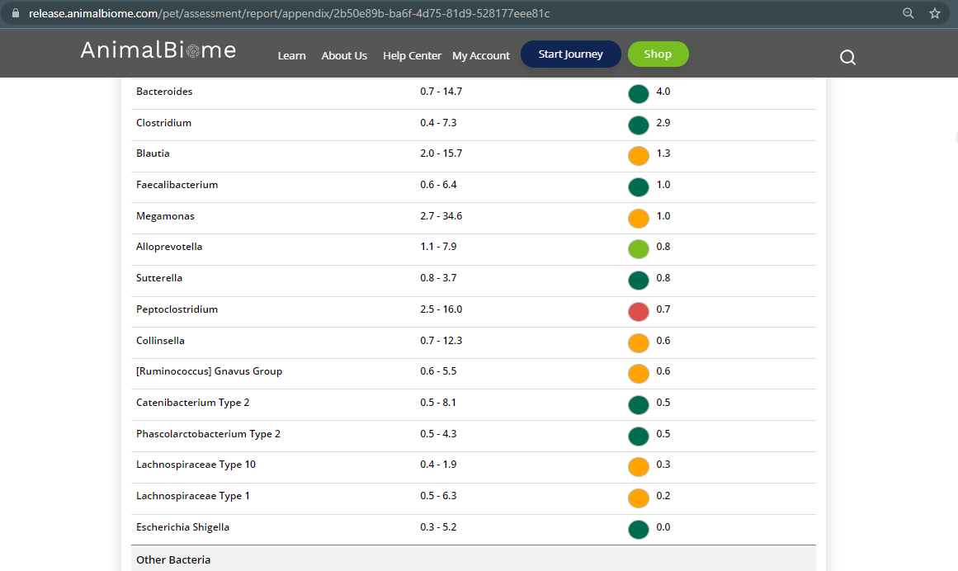



The result: **False True False False**

Expected result: Mild to Moderate

Achieved result: passed

